How to setup DDNS

This article will guide you how to setup DDNS and the steps as below:
Model Number: F9 Question Classification: Remote WEB Management
Setup DDNS is: the purpose of broadband dial-up mode, WAN port IP generally changes after 24 hours, after the IP change, cannot be accessed through the IP address of the before, so set DDNS, through the domain name binding WAN IP, when the IP changes, directly through the domain name.

The computer can connect to the router via the Internet connection, it can be connected wirelessly to the router if it is a laptop.
Wired Connection:
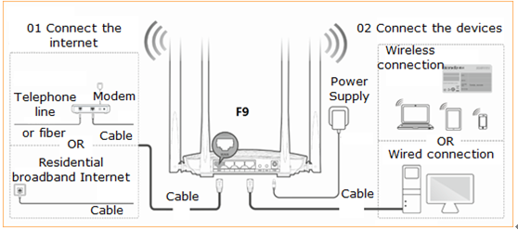

Wireless Connection:
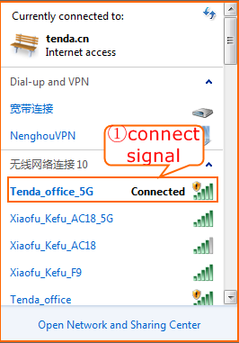

Open a browser then type http://tendawifi.com into the Address Bar and then press Enter. Typing login password in the homepage of router then click “Login”.
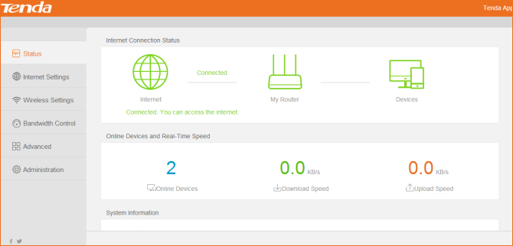

1、Choose "Advanced" - DDNS click "open" - service provider has three: oray.com, no-ip.com, dyn.com for selection.
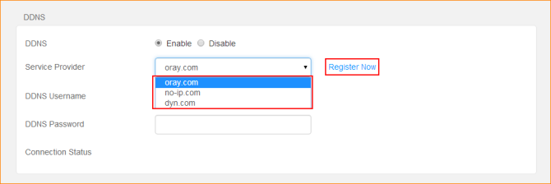

2、Take no-ip.com for example: the service provider selects "no-ip.com" and clicks "register to go" to no-ip.com to register and register to have a dynamic domain name.
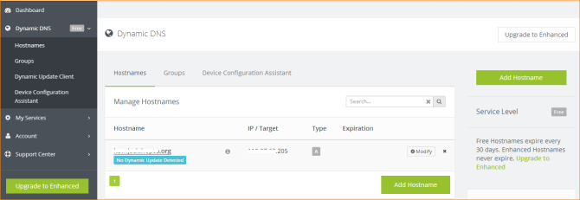

3、 the router interface, will be registered user name, password, and domain name "fill in, click" ok ", will see the connection status display "connection", when the connection status display "connected"
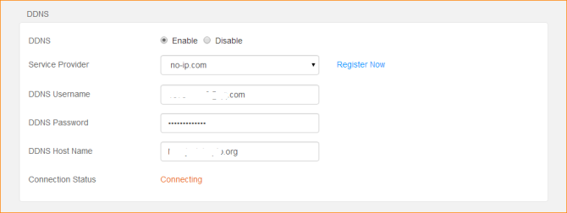

4、The connection status displays the "connected", indicating that the binding is successful.
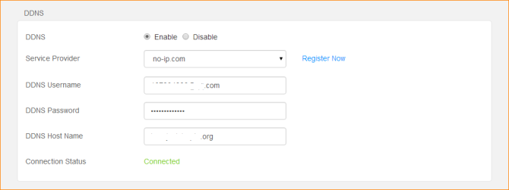

5、You can verify that the domain name binds the WAN port IP address. Authentication method: ping domain name, return IP if it is WAN port IP address, then indicate the binding success.
